**Group #11 - “Noble Owls”**

**HealthFuel**

**Executive Summary**

HealthFuel is a health and fitness tracking app designed to help its users reach their workout and diet goals. Users will enter all the starting stats including age, weight (lbs), level of familiarity with working out and dieting, and their goal weight. To keep users from procrastinating on their goals, they will also need to provide a deadline to keep them motivated.

Within the app, the user will be able to keep daily track of their calorie intake, and records of their exercises for that day. These records will then be saved to a graph showing the user’s weekly/monthly progress. There will be the opportunity to upload progress pictures as this has been a proven method to help with exercise motivation. Aside from the private tracking tools provided, different users of the app will have the opportunity to interact with each other by sharing healthy recipes that they like, workouts that they’ve tried/recommend, and any motivational posts they’d like to add.

It can feel daunting to look at the final goal as progress would seem so minor, so aside from the final goal, the user can set monthly “mini-goals” which are essentially milestones to help the user stay motivated and disciplined, as well as help them make sure they’re on track to reach their final goal.

**Competitive Analysis**

| **HealthFuel** | **Competitors** |
| --- | --- |
| * Easy to use * Enjoyable interactive platform * Easy understandable graphs * Distraction free * Open features to all users * Easy and motivating set goals supplemented by “mini goals” | * Complicated/ confusing to use * Boring platform * Messy, confusing graphs * Covered in ads and irrelevant content * Pay-to-use features * Intimidating goals that seem impossible to reach |

HealthFuel combines the interactions found on social media *and* the motivation users get from health trackers into an all-in-one package.

Other health trackers have a complicated system that is confusing and hard to follow or understand. Trackers that are easier to use, usually require their users to subscribe to a monthly payment for minimum benefits, such as Myfitnesspal who recently made their barcode scanning function a feature available only to premium members. HealthFuel will be completely free to use and all of its features will be available to every user, not blocked by a paywall.

Other social media platforms are plagued with irrelevant content that only serve to distract people from their goals. HealthFuel aims to filter out all unrelated content to help our users stay on track from reaching their goals. HealthFuel is solely meant to help people stay and track and stay motivated while enjoying and sharing the process.

**Data Definition**

* Primary Goal: The main goal that the user will be focusing on and aim to reach
* Deadline: A set date or time that the user decides on
* Mini-Goal: A side goal that will not be the main focus, but still remind the user of it
* Profile: A page where users will be able to see their progress, recipes, workouts, as well as others
* Graphs: Compiled set of the user’s current weight (lb) or calorie intake show as a line graph organized into weeks or months

(editing. . .)

**Overview, scenarios, and use cases**

1. Community

Those who use this health tracker app would be able to find and connect with like-minded people with similar goals as well as encourage others to stay on track whether their goal is eating healthier or working out more. Users can also share their favorite healthy food recipes with each other or recommended diets or workout regiments that fit the needs of specific users. This would also foster an encouraging, non-judgmental environment which is essential for helping people improve themselves. Users could also have healthy competition with others, which can further motivate them to achieve or even go beyond their fitness goals.

1. Personalization

This app would also be able to show the users progress through personalized fitness and nutrition tracking. This helps users stay accountable to themselves throughout their fitness journey. This app will allow users to develop their own personal workout plans based on the user’s goals, current level of fitness and availability of workout equipment.

1. Challenges

In the beginning when there are not as many users of the app, there may not be many food recipes to use as reference or inspiration. But as more and more users join the app, the diversity of these recipes will increase as well. There is also the challenge of ensuring consistent usage of the app. There may be many who download the app but not use it regularly. Therefore it is important that this app is both easy to use and engaging to ensure the maximum amount of user retention.

1. Rewards

There can also be a reward based system in place based on specific exercises, diet goals or fitness level. Upon completing a challenge, the user could be rewarded with a badge on their profile. Some examples of these badges could be staying within a recommended calorie limit or doing a certain number of workouts. Some could be as daily rewards for simply logging into the app.

1. Setting Goals

Users would be able to select particular fitness goals, such as losing weight or bulking up and the app would be able to provide recommendations for diets or exercise methods based around the given goals by the user. The app would also be able to provide feedback on their goals as they progress. However, the app would also be able to alert the user if their goal would be considered “too extreme” for their body type (height, weight, etc.)

**High-level functional requirements**

1. Keep track of calorie intake

Users will be able to login daily and keep track of their daily calorie intake by inputting the number of calories of their meals/snacks and see a final count of their total intake for a given day. This would help the user stay within the limits they’ve set for themselves.

1. Post private progress pictures

Users will be able to have a feed (similar to an instagram feed) of their progress pictures so they can see all the changes in their body as they happen. This will be a feed that only the posting user can view as taking progress pictures during a health journey can be very vulnerable so we want our users to feel safe posting them knowing there’s absolutely no judgment. Also, we realize that different people have different goals in terms of which body part they’d like to work on, so this would make it appropriate to post any body part they’d like.

1. Share recipes and workouts

This will be a separate feed where different users can share healthy recipes they’ve either found online or created themselves. They’ll be able to specify if the recipe is related to a specific diet and any tips/substitutions they recommend. Although this would be a low interaction feed, it’ll still give users that sense of community of being surrounded by people also striving to reach their health goals.

1. Keep record of what workouts they did on a given day

Keeping track of workouts is a very important, if not the most important, part of working out. This gives the user the opportunity to compare their current running times to their previous ones, or their current PRs(personal record: maximum weight they were able to successfully rep on a certain exercise) to previous ones so they can make sure their growth and improvement are consistent.

**Non-functional requirements**

1. Performance/Scalability

The results that are mainly needed to be returned would be the multi-user feeds. To prevent any latency, we will create a specific cell reload (ex: 20 cells at a time) with reusable cells so the software can call any cells out of view and reuse them to load more posts, instead of constantly creating new cells.

1. Portability/Compatibility

We will be using XCode, mainly swift and ruby, to create an ios app that would be compatible with iphones.

1. Usability

Part of our goal in making our users’ health journeys as successful as possible is creating a very straightforward and easy to use app. We do not wish to limit our users to only the tech-savvy so we are striving to limit as many steps as possible on then user’s end without jeopardizing app productivity.

**High-level system architecture**

* We will be using the apple app development tool Xcode to develop this app.
* Programming languages included will be mainly Swift and Ruby
* APIs
  + MyFitnessPal API: <https://myfitnesspalapi.com/docs/about/>
* Frameworks
  + UIKit for Frontend development: <https://getuikit.com/>
  + Parse for backend development:<https://docs.parseplatform.org/>
* Systems used
  + MacOS/IOS
  + Windows

**Team**

* Product Owner:
  + Justin Rivera
* Scrum Master:
  + Mohannad Darwish
* Dev Team:
  + Jean-Patrick Gabon
  + Eric Compbell
  + Jadyn Frank

**Checklist**

* Our main source of communication is a discord group as it’s the most convenient for everyone.
* Availabilities:

|  | **Sun.** | **Mon.** | **Tues.** | **Wed.** | **Thur.** | **Fri.** | **Sat.** |
| --- | --- | --- | --- | --- | --- | --- | --- |
| **Patrick** | All day | After 3pm | 9am-12pm  3pm-8pm | After 3pm | 9am-12pm  3pm-8pm | After 3pm | All day |
| **Jadyn** | All day | All day | After 2pm | After 3pm | After 2pm | After 3pm | All day |
| **Eric** | All day | After 1pm | All day | 10am-7pm | 9am-3pm | All day | All day |
| **Justin** | 2pm-  10pm | Unavailable | 9am-3pm | 11am-9pm | 9am-3pm | 11am-9pm | 9am-12pm |
| **Mohannad** | 9am - 3:30pm | 7:30am - 2pm | Unavailable | Unavailable | 2pm - 6pm | 4:30pm - 11pm | 1pm - 11pm |

* Front and back end team leads:
  + **Front end:** Jean-Patrick Gabon
  + **Back end:** Mohannad Darwish
* Github master:
  + Jadyn Frank
* We have discussed everyone’s experience and strengths, and assigned roles accordingly.

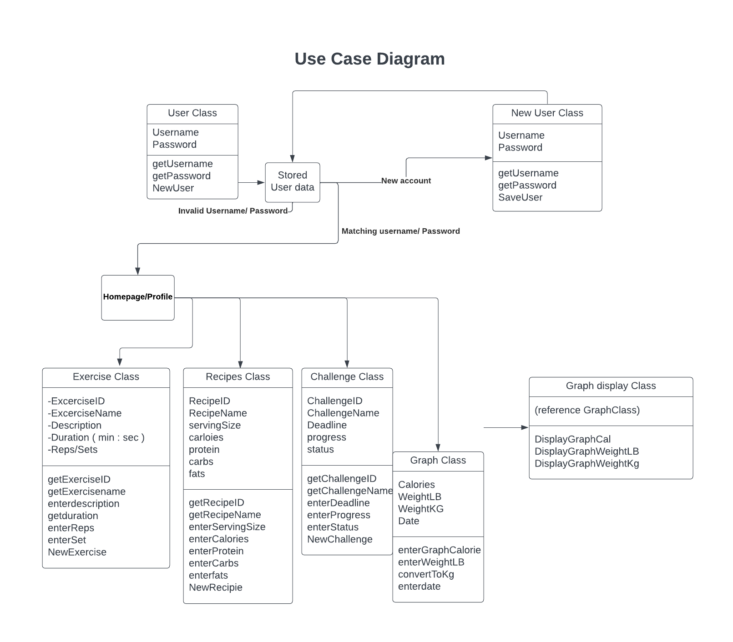

Deployment Diagram

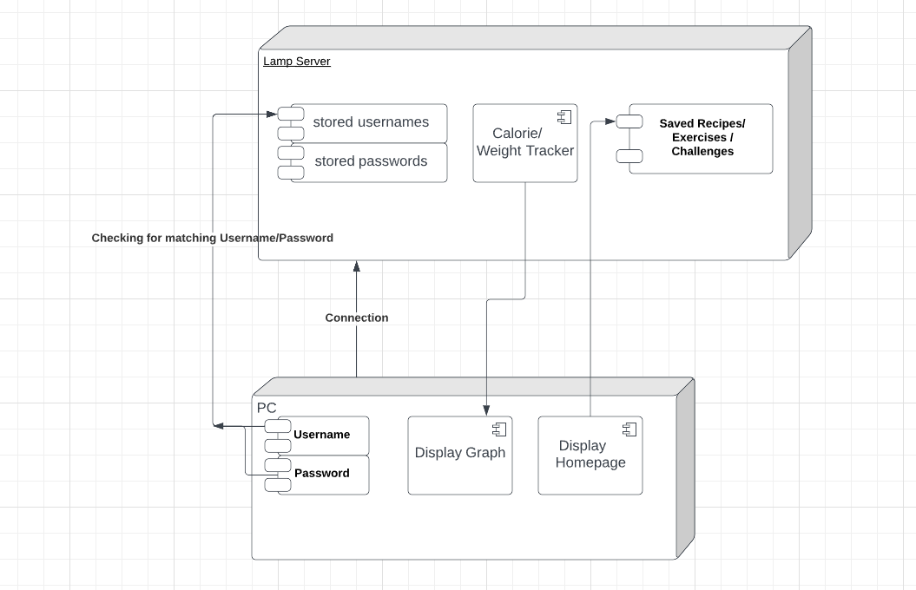

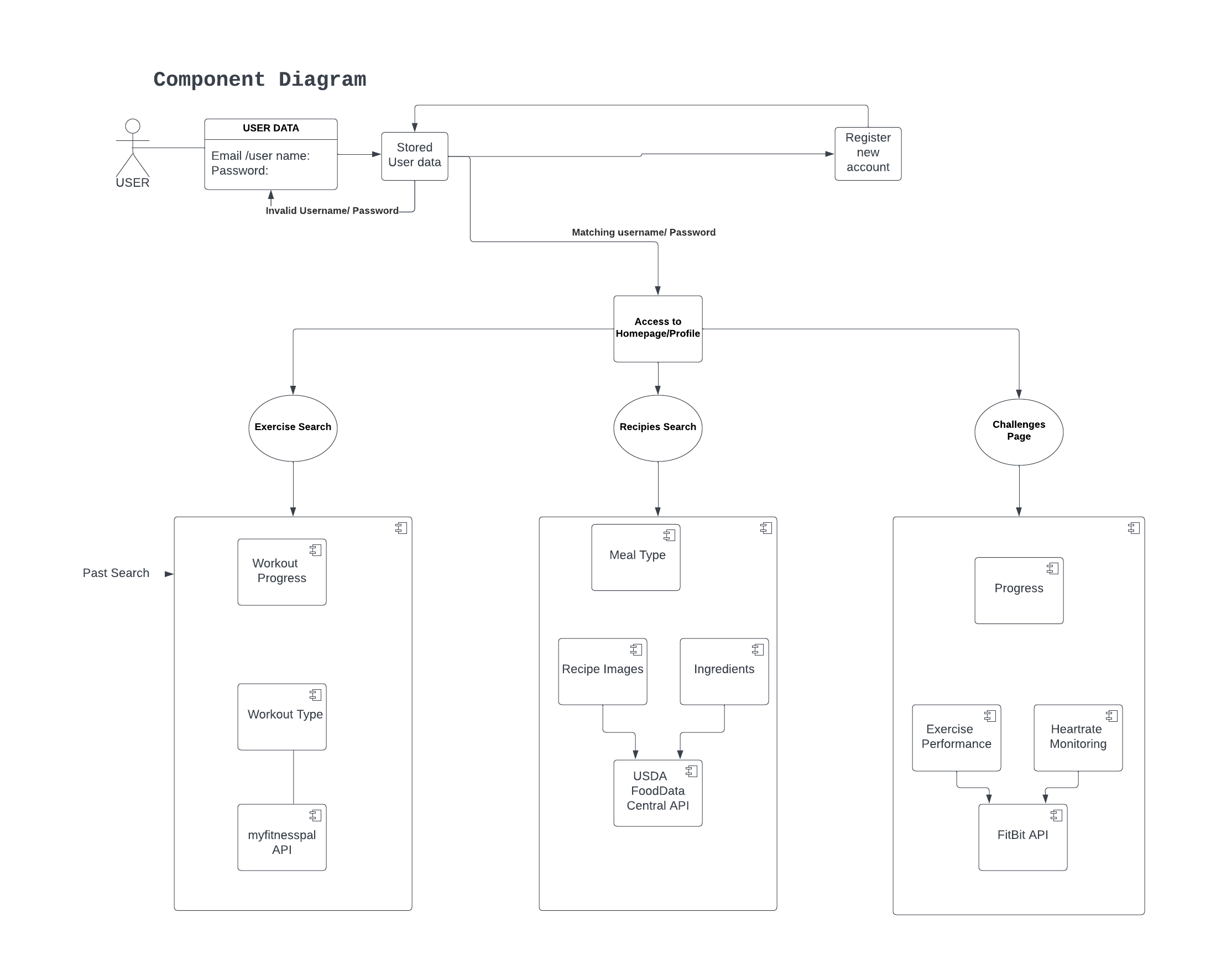

**Key risks**

1. Skills risks: Several skills risks are associated with developing a health tracker app. These may include our team having to obtain the right skills to design, develop, test, and deploy the app, as well as having the necessary knowledge of data privacy and security regulations.
2. Schedule risks: Developing a health tracker app requires a significant commitment of time and resources. Schedule risks may be associated with meeting deadlines, managing resources, and dealing with unforeseen obstacles as a team.
3. Technical risks: Developing a health tracker app involves technical challenges such as integrating different types of data from various sources, ensuring the accuracy and reliability of data, and maintaining the app's functionality across other platforms and devices.
4. Teamwork risks: Developing a health tracker app involves working collaboratively with a team of professionals, including designers, developers, testers, and project managers; not all of us are of the same skill set, so there may be a consolidation of tedious tasks amongst a few people, but as a team, we will make it work.
5. Data privacy risks: Health data is sensitive and subject to strict regulations such as HIPAA in the US or GDPR in the EU. Developing a health tracker app requires our team to thoroughly understand these regulations to implement the appropriate data privacy and security measures to protect users' personal information.
6. User adoption risks: Developing a health tracker app is pointless if users do not adopt and use it. There may be risks associated with user adoption, such as creating a user-friendly app that meets the needs of its target audience and offers a compelling value proposition.
7. Integration risks: Health tracker apps often integrate with various data sources, such as fitness trackers, electronic medical records, and other health-related apps. There may be risks associated with integrating these disparate sources, including technical challenges and data accuracy issues.
8. Competitive risks: Health tracker apps are a highly competitive market, and there may be risks associated with our team developing an app that stands out from the competition, offers unique features or functionality, and provides value to our users.

**Prototypes**

* We initially started working on our prototypes on Figma but their app kept crashing and just causing a lot of issues. We got the idea to make our prototypes on XCode instead, and after some research we were able to verify that it is applicable to do so (we verified that the milestone instructions did not specify the use of a certain app/software).
* Parse has started being implemented into our code and, as can be seen in the prototype, we’ve created some sample entries into the database to make sure everything is working as it should be.
* Prototype demo link: <https://youtube.com/shorts/p9nwEwgL1JM>